AKT Sample Questions

Questions are derived from accredited and referenced sources, including review articles and original papers in journals readily available to all general practitioners: primarily from Clinical Evidence, British Medical Journal, NICE Guidelines, British Journal of General Practice, Drugs and Therapeutics Bulletin or Cochrane Reviews.

Occasionally a question may use original material from published papers, and the item may take longer to complete. This variation in question time will have been taken into account in constructing the total paper.

The current edition of the British National Formulary is the reference source for therapeutics questions, including the general information on prescribing. Some questions may refer to the unlicensed but widely accepted use of specific drugs.

Some of these questions relate to current best practice. They should be answered in relation to published evidence and not according to an individual’s local arrangements.

Calculators are NOT necessary for statistical questions, and so will NOT be allowed.

Pictorial data such as charts, risk charts and photographs may be included in the questions.

The paper contains a number of different format questions including some or all of the following:

Extending Matching Questions (EMQ) in which a scenario has to be matched to an answer from a list of options. You may feel that there are several possible answers but you must choose only the most likely from the option list.

THEME: Reduced Vision

Option list:

A Basilar migraine F Occlusion of the central retinal vein
B Cerebral tumour G Optic neuritis
C Cranial arteritis H Retinal detachment
D Macular degeneration I Tobacco optic neuropathy
E Occlusion of the central retinal artery

Instruction:
For each patient with reduced vision, select the single most likely diagnosis. Each option may be used once, more than once, or not at all.

Items:
1 A 75-year-old man, who is a heavy smoker, with blood pressure of 170/105, complains of floaters in the right eye for many months and flashing lights in bright sunshine. He has now noticed a ‘curtain’ across the vision of his right eye.

2 A 70-year-old woman complains of shadows, which sometimes obscure her vision for a few minutes. She has felt unwell recently with loss of weight and face pain when chewing food.

3 A 45-year-old woman, who is a heavy smoker, with blood pressure of 170/110, complains of impaired vision in the left eye. She has difficulty discriminating colours and has noticed that her eye aches when looking to the side.

THEME: Contraceptive advice

A 7 days of extra contraceptive precautions required
B 14 days of extra contraceptive precautions required
C Emergency contraception required
D No extra precautions required
E Omit pill free week

For each patient described below, select the single most appropriate statement of advice from the list above. Each option may be used once, more than once or not at all

4 A 24-year-old woman is taking the combined contraceptive pill. She is on day 19 of the packet and rings to say that she forgot her pill yesterday morning and had intercourse last night. She has taken her pill this morning. Her last period was normal and she has taken all the other pills accurately.

5 A 36-year-old woman is taking the progesterone only pill. She is on day 14 of the packet and rings to say that she forgot her pill yesterday and had intercourse last night. She has taken her pill this morning. Her last period was normal and she has taken all the other pills accurately.

6 A 28-year-old woman had her first baby 8 weeks ago. She is not breast feeding and wishes to restart contraception straight away. She has not started menstruating yet has and receives her first dose of Depo-Provera that day.

7 A 26-year-old woman is taking the combined contraceptive pill. She forgot to start her new packet of pills 3 days ago and had intercourse last night. Her last period was normal and she had taken her previous pack of pills accurately.

8 A 24-year-old woman is taking the combined contraceptive pill. She is on day 19 of the packet and requires erythromycin for a skin infection as she is allergic to penicillin.

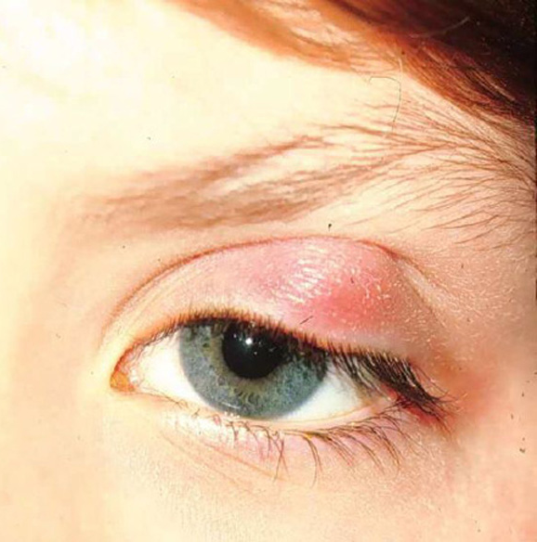
Picture Format

THEME: Eye problems

9 A 42-year-old woman who
has previously had treatment for
cervical CIN 2, has had a lump
affecting her left upper lid for
three months. It is asymptomatic.

What is the single most likely
diagnosis in this patient?
Select one answer only

A entropion
B meibomian cyst
C metastatic deposit
D stye
E xanthelasma

Single Best Answer (SBA) questions in which a statement or stem is followed by a variable number of items, only one of which is correct.

10 According to current evidence, in the management of croup in a 2-year-old child, which is the single most effective treatment to shorten the course of the condition? Select one option only.

A Place the child in a steam filled bathroom
B Administer inhaled budesonide
C Prescribe amoxicillin 125 mg t.d.s. for five days
D Administer inhaled salbutamol
E Prescribe paediatric cough suppressant containing codeine
F Administer inhaled tribavirin

11 Which ONE of the following plasma glucose levels (on two occasions) is diagnostic of diabetes mellitus? Select one option only.

A Fasting plasma glucose >5 mmol/L
B Fasting plasma glucose >6 mmol/L
C Fasting plasma glucose >7 mmol/L
D Random plasma glucose >10 mmol/L
E Random plasma glucose >9 mmol/L

12 According to current evidence, which ONE of the following drugs produces the MOST significant reduction in menstrual flow for women with menorrhagia? Select one option only.

A diclofenac
B ethamsylate
C flurbiprofen
D mefenamic acid
E norethisterone
F tranexamic acid

13 An 18-year-old patient presents with a two day exacerbation of asthma following a worsening of hay fever. After a salbutamol nebuliser her peak flow rate increases from 250 to 450L/minute and she feels much better.

Which is the SINGLE MOST appropriate next management step? Select one option only.

A Nebulised salbutamol as required
B No further treatment
C Oral amoxicillin
D Oral chlorphenamine
E Oral prednisolone

Table/Algorithm Completion is the format often found in guidelines to advise on management decisions. You are asked to select the correct answer to complete the table or diagram.

THEME: Medical management of menorrhagia
Not requiring contraception
Requiring contraception

(14) -------
(15) -------
Combined oral contraceptive pill
(16) ---------

For each of the numbered gaps above, select ONE option from the list below to complete the algorithm, based on current evidence. Select ONE option only

A Copper intra-uterine device
B Cyclical medroxyprogesterone acetate
C Cyclical norethisterone
D Inert intra-uterine device
E Levonorgestrel releasing intra-uterine system
F Mefenamic acid
G Nonoxinol ‘9’
H Tibolone
I Tranexamic acid

THEME: NHS breast screening referral guidelines

For each numbered question, select the CORRECT option to complete the algorithm from the list below. Each answer may be used once, more than once or not at all.
The diagram for this question is on the next page.

A age 25
B age 35
C age 45
D age 55
E Discrete lump
F Dominant asymmetrical nodularity
G Symmetrical nodularity
H Refer
I Review
J Reassure

History
Examine
No lump
(17)
Dominant asymmetrical nodularity
Age< (18), no family history
< (19) years
+ strong family history
OR
> (20) years
Review 6 weeks
Reassure
? Reassess
(21)
Refer
Nodularity gone - reassure
(22)

These 22 questions should have taken you about 20 minutes

